**AWS EC2 Linux OS**

**By: Kevin Litchmore**

**Create EC2 Instance using Windows OS**

Step 1: Click “EC2” or “EC2 Dashboard”.

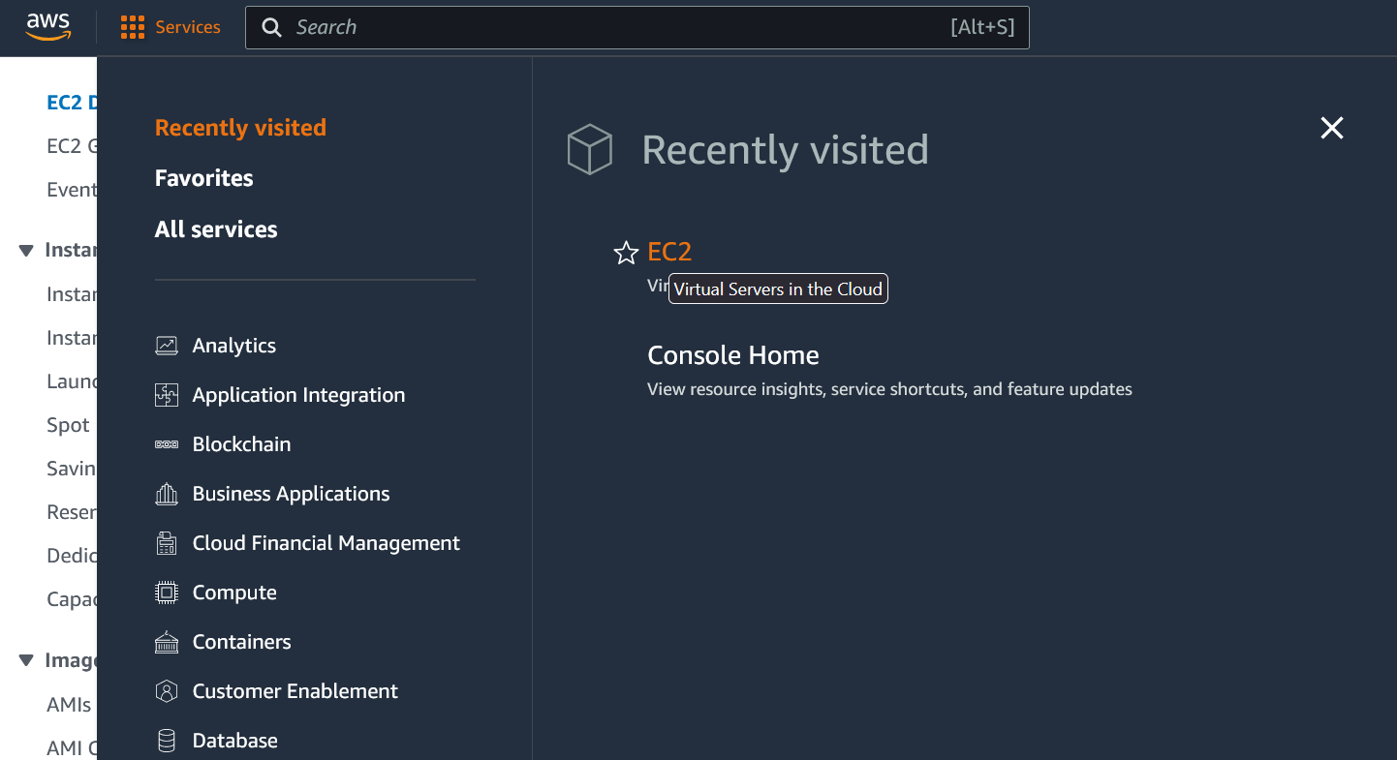

Step 2: Click “Launch instance”.

Step 3: Choose the Linux Amazon Machine Image (AMI) (Creating tags is optional).

Step 4:

* For this case we will keep the default values for the “instance type” and continue to key pair.
* We will create a key pair to securely access the instances after they are created. To do this select “Create new key pair”.
* Now create a name then select RSA.
* Next, we select. pem since we will be using the command prompt to access this instance later.
* Now select “Create key pair”.

Step 5:

* For the Network settings we will use the default VPC.
* The subnet availability zone we will be using is the first option. Please note that this will vary due to your AWS region. Since we are using Ohio the “Availability Zone”: us-east-2a will do since it is in the same region.
* Optionally: We change the security group name to “KevinINCRDPSecured”. Then we ensure that the security group rule “Type” is RDP and the source type is “My IP”.

Step 6: Scroll down and select “Launch instance”.

When we launch the instance, it will state that the instance has been successfully initiated.

Step 7:

* Now select “Connect to instance”.
* By default, the tab will be on session manager. Select RDP client to continue.
* Now we navigate to the search bar on your windows computer then type RDP.
* Now, Select Remote Desktop Connection

Step 8: Copy and paste the Public DNS into the computer field and select connect.

* Now a pop-up will appear where we will select “Yes” as seen below.

Step 9:

Copy the username information for your instance (The username is located on the right side of the screen next to the “Public DNS”).

* Now we need to get the password for the instance.

Step 10: Select “Get Password” located under Public DNS

Step 11:

Select upload private key file. (By default, this can be found in the downloads folder with the extension of. pem.

* Now we select Decrypt password.
* Once the password has been decrypted the password will now be visible. Copy the password and paste it in your Remote Desktop Program.

When successful your Windows instance will appear as the following image:

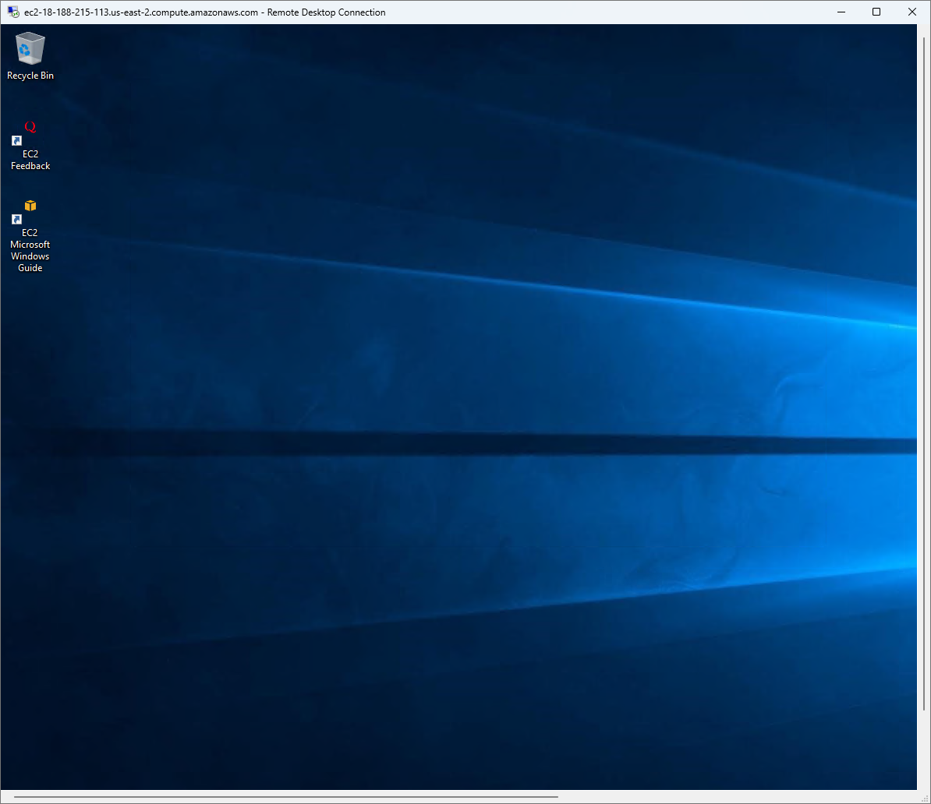

**Functionality Verification**

Step 1: verify the network connection by successfully navigating to google.com

